Public Portal Instructions

When a request for fiscal impact is sent to you, you will receive a notification via email, and the request can be found here:
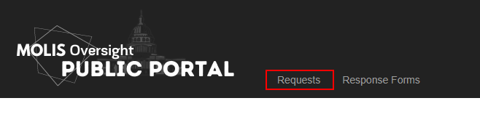
The forms to be used in your response can be downloaded here:
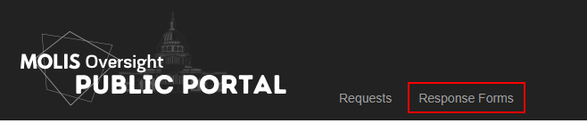
A record can be marked as “Tentative Due”, “Hard Due”, or “Withdrawn.” If a record is marked “Hard Due” this means the response is strictly required by the given date. “Tentative Due” indicates that a response may or may not be needed for that specific legislation version. “Withdrawn” means that you no longer need to submit a response for this version.
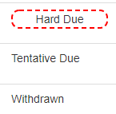
There is a search field and sortable columns to aid in sorting and finding a specific version.

To View the request/attachments the analyst has sent, click number 1 in the below picture:
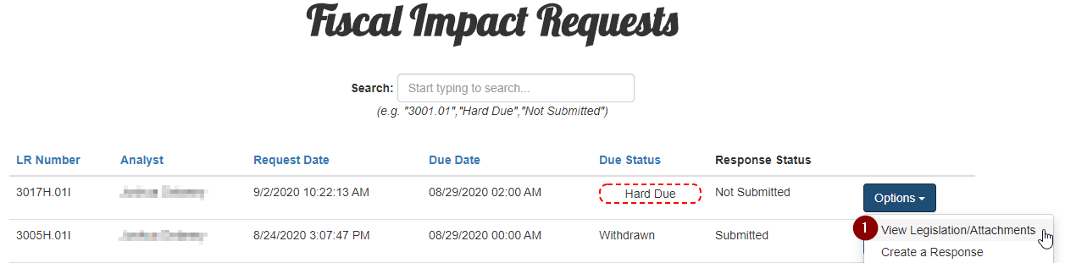

That will open up a window where you can download/view the request file and attachments
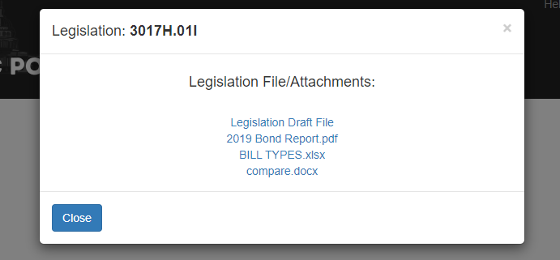
To create a response click number 2 in the below picture:
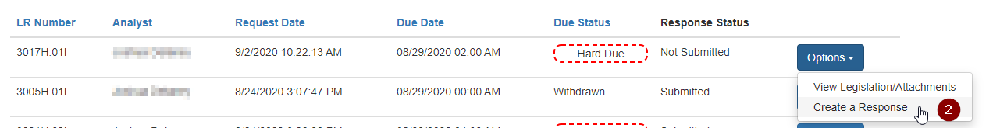

When referencing the below picture:
- Section 1 allows you to designate whether your response implies impact, or implies no impact.
- Section 2 is where you would upload files that were downloaded from the “response forms” page.
- Section 3 is where any additional attachments can be included
- Section 4 is where any additional notes or comments for the response can be entered.
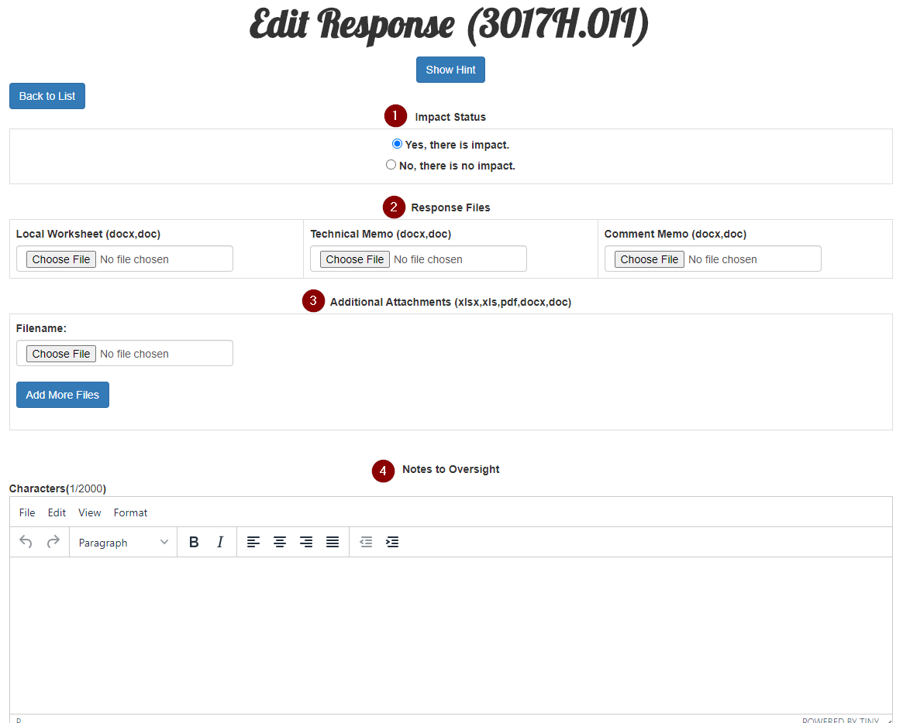

If you’d like to save the response and come back and edit it later, you’d press button number 1 in the picture below. If you’d like to save and submit right away, you’d press button number 2.

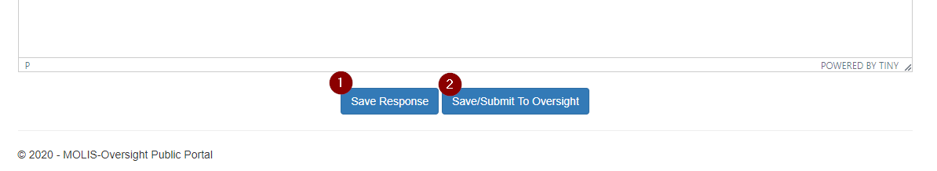
To edit the saved response, click button number 1. To go ahead and submit the response to oversight, click button number 2.
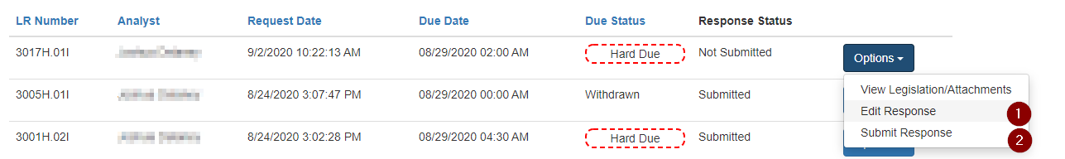

You have the option to:
- Create a revised response. (this means replacing your existing submitted response)
- View the response you submitted. (this will show all of your responses for this version)
- Update the response you submitted. (the response can be added to but not changed)
